***Contents***

*Use* ***for-loop*** *to write a reference function*

***Open-loop system***

1. *Continuous-time system simulation*

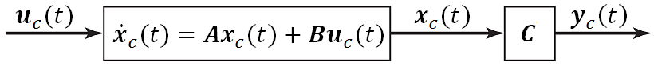

1. *Discrete-time system simulation*

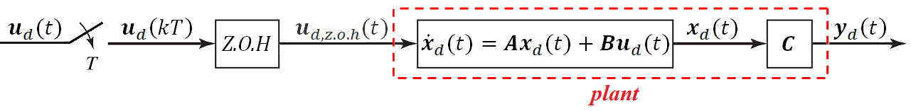

***Closed-loop system***

1. *Continuous-time system plus* ***controller*** *simulation*

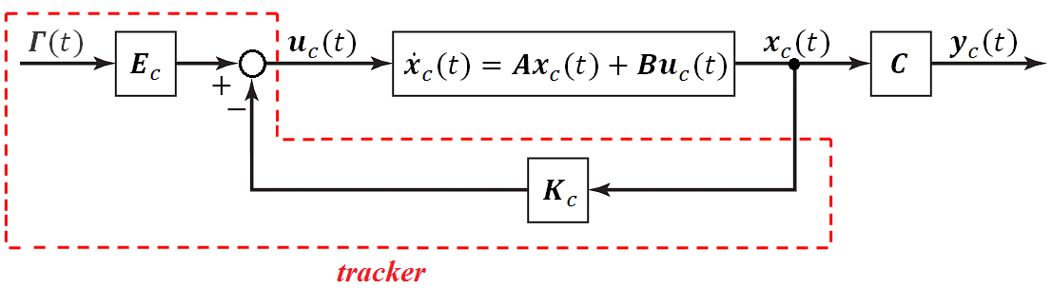

1. *Discrete-time system plus* ***controller*** *simulation*

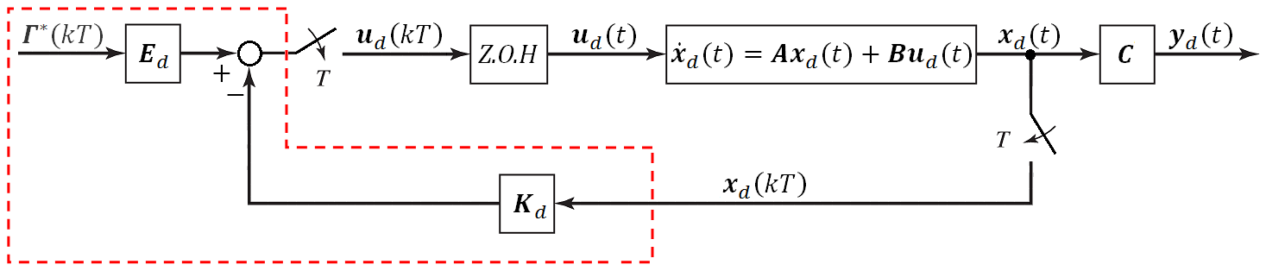

***Open-loop system***

1. *Continuous-time system plus* ***observer*** *simulation*

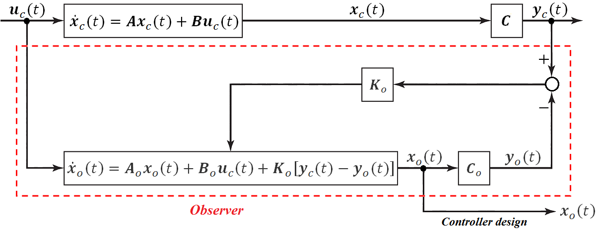

1. *Discrete-time system plus* ***observer*** *simulation*

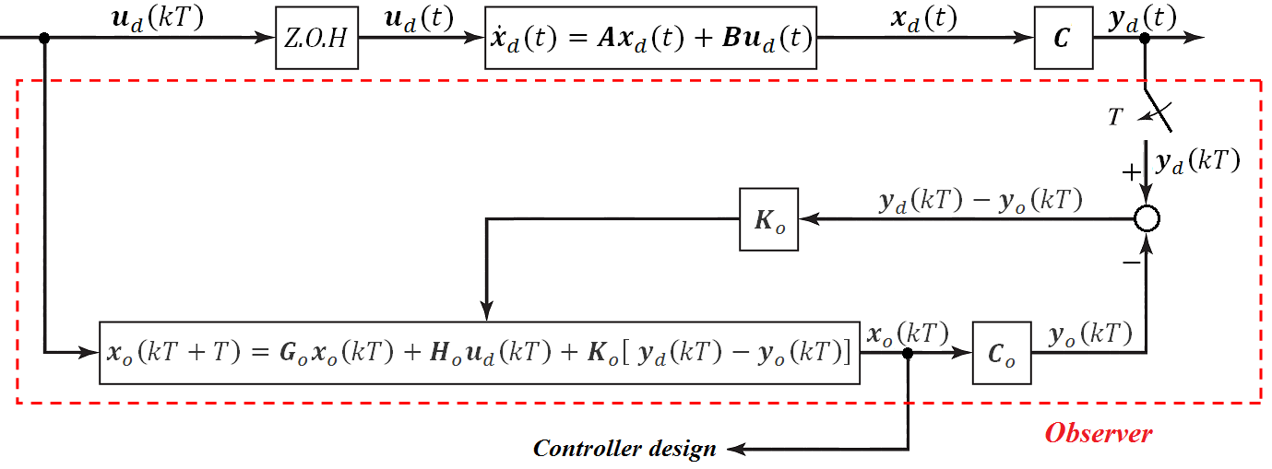

***Closed-loop system***

1. *Continuous-time system plus* ***observer*** *and* ***controller*** *simulation*

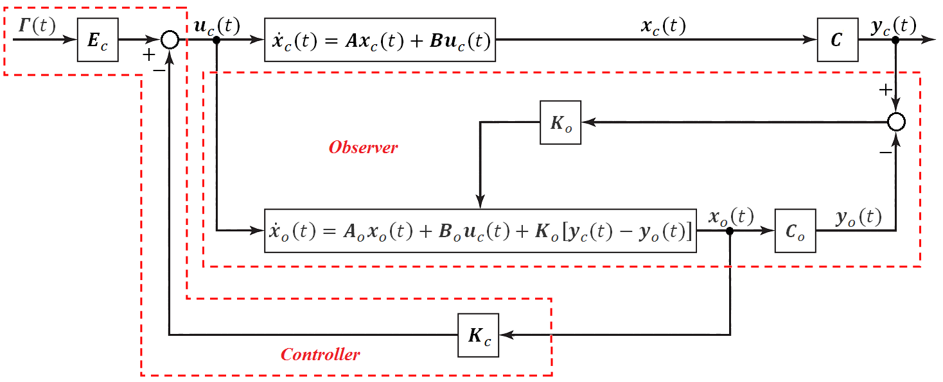

1. *Discrete-time system plus* ***observer*** *and* ***controller*** *simulation*

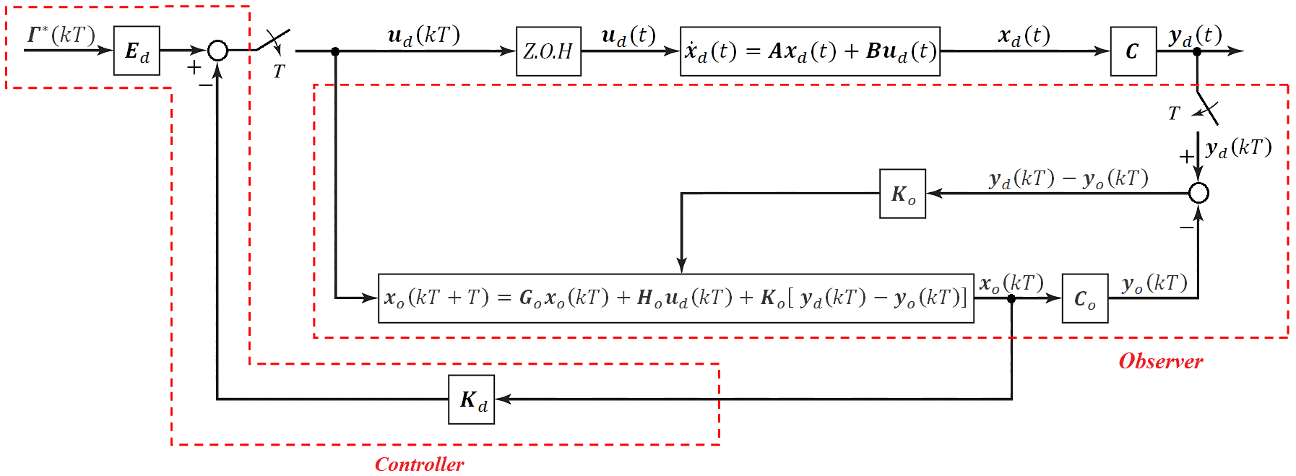

***Open-loop system***

1. *Continuous-time system plus* ***OKID*** *simulation*
2. *Discrete-time system plus* ***OKID*** *simulation*

***Closed-loop system***

1. *Continuous-time system plus* ***OKID*** *and* ***controller*** *simulation*
2. *Discrete-time system plus* ***OKID*** *and* ***controller*** *simulation*

***Twelve types* :**

$$Systems \left\{ \begin{aligned} Continuous-time \left\{ \begin{aligned} Open-loop \left\{ \begin{aligned}pure \\ Observer \\ OKID \end{aligned}\right. \\ Closed-loop \left\{ \begin{aligned}Controller \\ Observer plus Controller \\ OKID plus Controller \end{aligned}\right.\end{aligned}\right. \\ Discrete-time \left\{ \begin{aligned} Open-loop \left\{ \begin{aligned}pure \\ Observer \\ OKID \end{aligned}\right. \\ Closed-loop \left\{ \begin{aligned}Controller \\ Observer plus Controller \\ OKID plus Controller \end{aligned}\right.\end{aligned}\right.\end{aligned}\right.$$

***Design procedure* :**

*Step 1* : Optimal Linearization

*Step 2* : State Estimator

*Step 3* : Analog Linear Quadratic Tracker

*Step 4* : Digital Redesign

*Step 5* : Perform Simulation